Design Application Architecture

Estimated time: 60 minutes

Requirements  
Tailwind Traders is looking to update their website to include customer supplied product  
images in addition to the already existing photos provided by marketing. They believe that  
having more photos of products in use will give potential customers a better feel for how past customers loved their products after purchasing them. They do have some requirements as outlined below:

* Uploaded images will need to be scanned before getting posted on the website. Legal and Marketing are both requesting that after initial upload, the images be checked for any issues that reflect poorly upon the company or could cause legal issues. An inhouse API has already been developed and deployed that can perform the necessary scanning.
* Based on existing patterns, Tailwind Traders expects the image uploads to happen very unevenly throughout the day. Certain periods may experience more uploads than the scanning software can handle, while other periods may experience very few or no uploads.
* Once an uploaded image has been scanned and approved by the system, Tailwind  
  Traders would like for the customer to be sent an email thanking them for sharing their image.
* Cost and management of the solution is a concern, especially since Tailwind Traders  
  isn’t sure how popular this feature will be initially. Minimize costs and leverage  
  serverless solutions where possible.

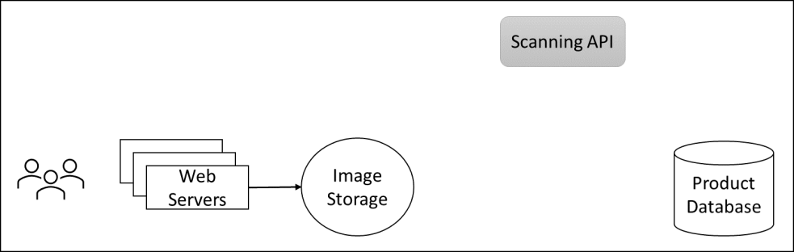

Task  
Design an architecture for the customer images to be added to the company website.

* Where should the images be stored?  
  How will you ensure that images being stored get scanned even when the uploads are outpacing scanning?
* Once images are approved and the catalog database is updated, how will the customer be notified?

**Your Solutions:**